Final Project Wrangle OpenStreetMap Data with MongoDb



Author: Paulina Grunwald

E-mail: [paulina.grunwald@gmail.com](mailto:paulina.grunwald@gmail.com)

Map Area: The Hague , The Netherlands

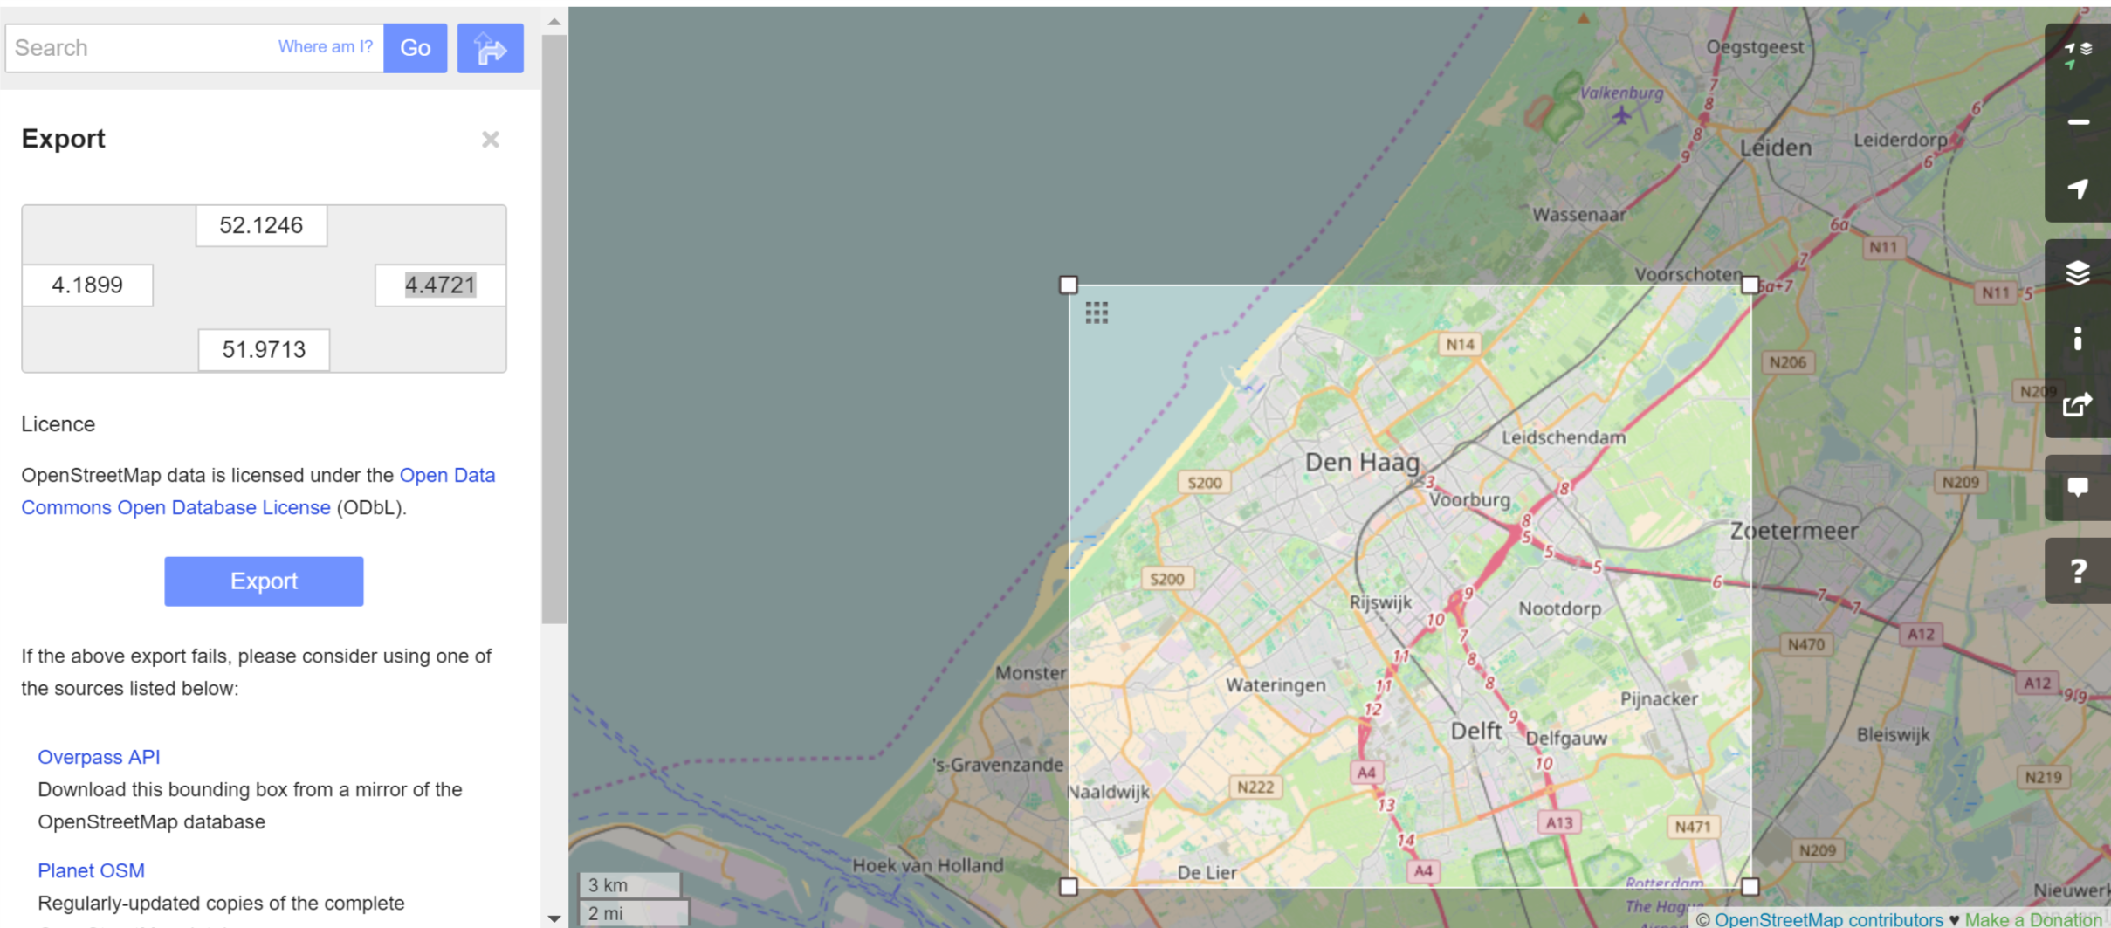

1. Problems Encountered in the Map

# 2. Data Overview

Summary statistics of the dataset:

* Number of the documents:
* Number of unique users:
* Number of nodes:
* Number of ways: